



**TEMPERATURE BASED AUTOMATIC REGULATOR USING ARDUINO**

##### A MINOR PROJECT – III REPORT

###### ***Submitted by***

|  |  |
| --- | --- |
| **SATHIYADHARSHINI B** | **927621BEC190** |
|  |  |

###### 

##### 

**BACHELOR OF ENGINEERING**

in

**DEPARTMENT OF ELECTRONICS AND COMMUNICATION ENGINEERING**

**M.KUMARASAMY COLLEGE OF ENGINEERING**

(Autonomous)

**KARUR – 639 113**

**NOVEMBER-2023**

**M.KUMARASAMY COLLEGE OF ENGINEERING, KARUR**

**BONAFIDE CERTIFICATE**

Certifiedthatthis **18ECP105 - Minor Project III** report “**TEMPERATURE BASED AUTOMATIC REGULATOR USING ARDUINO”** is the bonafide workof “**NAVEENA K (927621BEC136), RENUGA K (927621BEC165) , SATHIYADHARSHINI B (927621BEC190)”**who carried out the project work under my supervision in the academic year 2023-2024 – ODD.

**SIGNATURE SIGNATURE**

**Dr.A.KAVITHA B.E., M.E., Ph.D.,** **Mrs.T.ABIRAMI,M.E.,(Ph.D.,)**

**HEAD OF THE DEPARTMENT, SUPERVISOR,**

Professor, Assistant Professor,

Department of Electronics and Department of Electronics and

Communication Engineering, Communication Engineering,

M.Kumarasamy College of Engineering, M.Kumarasamy College of Engineering, Thalavapalayam, Thalavapalayam,

Karur-639113. Karur-639113.

This report has been submitted for the **18ECP105 – Minor Project-III** final review held at M. Kumarasamy College of Engineering, Karur on **13-10-2023.**

**PROJECT COORDINATOR**

**INSTITUTION VISION AND MISSION**

**Vision**

To emerge as a leader among the top institutions in the field of technical education.

**Mission**

**M1:** Produce smart technocrats with empirical knowledge who can surmount the global challenges.

**M2:** Create a diverse, fully -engaged, learner -centric campus environment to provide quality education to the students.

**M3:** Maintain mutually beneficial partnerships with our alumni, industry and professional associations

**DEPARTMENT VISION, MISSION, PEO, PO AND PSO**

**Vision**

To empower the Electronics and Communication Engineering students with emerging technologies, professionalism, innovative research and social responsibility.

**Mission**

**M1:** Attain the academic excellence through innovative teaching learning process, research areas & laboratories and Consultancy projects.

**M2:** Inculcate the students in problem solving and lifelong learning ability.

**M3:** Provide entrepreneurial skills and leadership qualities.

**M4:** Render the technical knowledge and skills of faculty members.

**Program Educational Objectives**

**PEO1:** **Core Competence:** Graduates will have a successful career in academia or industry associated with Electronics and Communication Engineering

**PEO2:** **Professionalism:** Graduates will provide feasible solutions for the challenging problems through comprehensive research and innovation in the allied areas of Electronics and Communication Engineering.

**PEO3:** **Lifelong Learning:** Graduates will contribute to the social needs through lifelong learning, practicing professional ethics and leadership quality

**Program Outcomes**

**PO 1: Engineering knowledge:** Apply the knowledge of mathematics, science, engineering fundamentals, and an engineering specialization to the solution of complex engineering problems.

**PO 2: Problem analysis:** Identify, formulate, review research literature, and analyze complex engineering problems reaching substantiated conclusions using first principles of mathematics, natural sciences, and engineering sciences.

**PO 3: Design/development of solutions:** Design solutions for complex engineering problems and design system components or processes that meet the specified needs with appropriate consideration for the public health and safety, and the cultural, societal, and environmental considerations.

**PO 4: Conduct investigations of complex problems:** Use research-based knowledge and research methods including design of experiments, analysis and interpretation of data, and synthesis of the information to provide valid conclusions.

**PO 5: Modern tool usage:** Create, select, and apply appropriate techniques, resources, and modern engineering and IT tools including prediction and modeling to complex engineering activities with an understanding of the limitations.

**PO 6: The engineer and society:** Apply reasoning informed by the contextual knowledge to assess societal, health, safety, legal and cultural issues and the consequent responsibilities relevant to the professional engineering practice.

**PO 7: Environment and sustainability:** Understand the impact of the professional engineering solutions in societal and environmental contexts, and demonstrate the knowledge of, and need for sustainable development.

**PO 8: Ethics:** Apply ethical principles and commit to professional ethics and responsibilities and norms of the engineering practice.

**PO 9: Individual and team work:** Function effectively as an individual, and as a member or leader in diverse teams, and in multidisciplinary settings.

**PO 10: Communication:** Communicate effectively on complex engineering activities with the engineering community and with society at large, such as, being able to comprehend and write effective reports and design documentation, make effective presentations, and give and receive clear instructions.

**PO 11: Project management and finance:** Demonstrate knowledge and understanding of the engineering and management principles and apply these to one’s own work, as a member and leader in a team, to manage projects and in multidisciplinary environments.

**PO 12: Life-long learning:** Recognize the need for, and have the preparation and ability to engage in independent and life-long learning in the broadest context of technological change.

**Program Specific Outcomes**

**PSO1:** Applying knowledge in various areas, like Electronics, Communications, Signal processing, VLSI, Embedded systems etc., in the design and implementation of Engineering application.

**PSO2:** Able to solve complex problems in Electronics and Communication Engineering with analytical and managerial skills either independently or in team using latest hardware and software tools to fulfil the industrial expectations.

|  |  |
| --- | --- |
| **Abstract** | **Matching with POs, PSOs** |
| Temperature control Arduino Uno Temperature sensor LCD  display  1  Temperature control Arduino Uno Temperature sensor LCD  display  1  Temperature Control, Arduino NANO, Temperature Sensor, LCD Display | PO1, PO2, PO3, PO4, PO5, PO6, PO7, PO8, PO9, PO10, PO11, PO12, PSO1, PSO2 |

**ACKNOWLEDGEMENT**

Our sincere thanks to Thiru.M.Kumarasamy, Chairman and Dr.K.Ramakrishnan, Secretary of M.Kumarasamy College of Engineering for providing extraordinary infrastructure, which helped us to complete this project in time.

It is a great privilege for us to express our gratitude to Dr.B.S.Murugan., B.Tech., M.Tech., Ph.D., Principal for providing us right ambiance to carry out this project work.

We would like to thank Dr.A.Kavitha, Professor and Head, Department of Electronics and Communication Engineering for her unwavering moral support and constant encouragement towards the completion of this project work.

We offer our wholehearted thanks to our Project Supervisor, Mrs.T.Abirami, M.E.,(Ph.D.,) Assistant Professor, Department of Electronics and Communication Engineering for her precious guidance, tremendous supervision, kind cooperation, valuable suggestions, and support rendered in making our project successful.

We would like to thank our Minor Project Co-ordinator, Dr.K.Karthikeyan, B.E., M.Tech., Ph.D., Associate Professor, Department of Electronics and Communication Engineering for his kind cooperation and culminating in the successful completion of this project work. We are glad to thank all the Faculty Members of the Department of Electronics and Communication Engineering for extending a warm helping hand and valuable suggestions throughout the project. Words are boundless to thank our Parents and Friends for their motivation to complete this project successfully.

ABSTRACT

The idea behind the project This project is a standalone automatic fan speed controller that controls the speed of an electric fan according to our requirement. The sensed temperature and fan speed level values are simultaneously displayed on the LCD panel. It is very compact using few components and can be implemented for several applications including air conditioners, water heaters, The temperature sensor LM35senses the temperature and converts it into an electrical(analog) signal, which is applied to the microcontroller. The sensed and set values of the temperature are displayed on the16x2-line LCD. The micro controller drives Transistor to control the fan speed. This project uses regulated 12V, 2Apower supply. This project is easy to operate the fan speed based on the temperature without using any manual operations.

Keywords—Temperature Sensor, Arduino NANO, Temperature Sensor, LCD Display*.*

**TABLE OF CONTENTS**

|  |  |  |
| --- | --- | --- |
| **CHAPTER No.** | **CONTENTS** | **PAGE No.** |
|  | **Institution Vision and Mission** | iii |
|  | **Department Vision and Mission** | iii |
|  | **Department PEOs, POs and PSOs** | iv |
|  | **Abstract** | viii |
|  | **List of Tables** | xi |
|  | **List of Figures** | xii |
|  | **List of Abbreviations** | xiii |
| **1** | **INTRODUCTION** | **1** |
| **2** | **LITERATURE SURVEY** | **3** |
| **3** | **EXISTING SYSTEM`** | **5** |
| **4** | **PROPOSED SYSTEM** | **6** |
| **5** | **BLOCK DIAGRAM** | **7** |
| **6** | **COMPONEMTS** | **9** |
|  | 6.1 ARDUINO NANO  6.2 FAN  6.3 LCD DISPLAY  6.4 L7805  6.5 POWER SUPPLY  6.6 POTENTIO METER  6.7 DHT 11  6.8 LM35 |  |
| **7** | **SOFTWARE REQUIREMENT** | **15** |
| **8** | **WORKING MODULE** | **16** |
| **9** | **RESULT AND DISCUSSION** | **18** |
| **10** | **CONCLUSION AND FUTURE WORK** | **20** |

**APPENDICES 22**

**REFERENCES 23**

**LIST OF FIGURES**

|  |  |  |
| --- | --- | --- |
| **FIGURE No.** | **TITLE** | **PAGE NO** |
| 6.1 | ARDUINO NANO | 8 |
| 6.2 | DHT11 SENSOR | 9 |
| 6.3 | LM 35 SENSOR | 10 |
| 6.4 | LCD DISPLAY | 11 |
| 6.5 | VOLTAGE REGULATOR | 12 |
| 6.6 | TRANSISTOR | 13 |
| 8.1 | WORKING PRINCIPLE | 15 |
| 9.1 | OVERVIEW OF THE PROJECT | 18 |

**LIST OF ABBREVIATIONS**

|  |  |  |
| --- | --- | --- |
| **ACRONYM** |  | **ABBREVIATION** |
| DHT 11 | - | Digital Temperature and Humidity Sensor |
| LM 35 | - | Linear Model |
| LCD | - | Liquid Crystal Display |
|  |  |  |

CHAPTER 1  
 INTRODUCTION

The idea behind the project is to control the speed of the fan by difference in temperature. The Temperature variation in the fan is an different way to deal with the speed of the motor. It is a process in which the objects temperature is measured and the way of heat energy passes into or out of the object is correctly adjusted to achieve a stable temperature. This project attendances the design and simulation of the fan speed control system by using PWM technique based on the room temperature. The room temperature can be measured with the help of a Temperature Sensor. It has been used to measure the temperature of the room and the speed of the fan is varied according to the room temperature using Pulse Width Modulation technique[1].

In today's rapidly advancing world, the integration of technology into our daily lives has become increasingly prevalent. From smart homes to automation in industrial processes, technology plays a pivotal role in enhancing our comfort, convenience, and efficiency. One such area where technology has made significant strides is in the realm of temperature control. Temperature-based automatic regulation is not only essential for maintaining the comfort of our living spaces but is also crucial in various industries, from agriculture to manufacturing. This project introduces a Temperature-Based Automatic Regulator using the versatile Arduino platform, aiming to provide an efficient and cost-effective solution for maintaining desired temperature levels.

The advancement in technology, intelligent systems are introduced every day. Everything is getting more sophisticated and intelligible. There is an increase in the demand of cutting edge technology and smart electronic systems. Micro-controllers play a very important role in the development of the smart systems as brain is given to the system. Today, micro-controllers are used in many disciplines of life for carrying out automated tasks in a more accurate manner. Electric fan is one of the most well-known electrical device because of its cost effectiveness and low power consumption advantages. Fan can be turned on and off physically by using switch button. Where right now, change in the temperature won't give any adjustment in the fan speed. So, an automatic temperature control system technology is necessary for the controlling speed of fan according to the temperature changes.

The idea behind the project is to control the speed of the fan by difference in temperature. The Temperature variation in the fan is an different way to deal with the speed of the motor. It is a process in which the objects temperature is measured and the way of heat energy passes into or out of the object is correctly adjusted to achieve a stable temperature. This project attendances the design and simulation of the fan speed control system by using PWM technique based on the room temperature. How the room temperature can be measured? The answer to the simple question is with the help of a Temperature Sensor. It has been used to measure the temperature of the room and the speed of the fan is varied according to the room temperature using Pulse Width Modulation technique[2].

The microcontroller is mainly a single chip microprocessor suited for control and automation of advancement in technology, intelligent systems are introduced every day. Everything is getting more sophisticated and intelligible. There is machines and processes. Today, microcontrollers are used in many disciplines of life for carrying out automated tasks in a more accurate manner. Almost every modern-day device including air conditioners, power tools, toys, office machines employ microcontrollers for their operation. Microcontroller essentially

It consists of Central Processing Unit (CPU), timers and counters, interrupts, memory, input/output ports, Analog to digital converters (ADC) on a single chip. With this single chip integrated circuit design of the microcontroller the size of control board is reduced and power consumption is low.

**CHAPTER 2**

**LITERATURE REVIEW**

There are some abstractions of publications which are relevant to our proposed system. According to those publications we have included the information about existing system. The existing system has scope of upgrade. And existing system has some limitations. We have gathered lot of information from the literature and have discussed here. The information we have gathered which are about Automatic control fan using various electronic component and Arduino as well. We have got additional knowledge from particular publication about human sensing device. We have gathered knowledge about our proposed system from some article as well which has been published by an organization.

The Home automation system that uses Wi-Fi technology. System consists of three main components; web server, which presents system core that controls, and monitors users’ home and hardware interface module(Arduino PCB (ready-made), Wi-Fi shield PCB, 3 input alarms PCB, and 3 output actuators PCB.), which provides appropriate interface to sensors and actuator of home automation system. The System is better from the scalability and flexibility point of view than the commercially available home automation systems.

The User may use the same technology to login to the server web based application. .If server is connected to the internet, so remote users can access server web based application through the internet using compatible web browser. The application has been developed based on the android system. An interface card has been developed to assure communication between the remote user, server, raspberry pi card and the home Appliances.

The application has been installed on an android Smartphone, a web server, and a raspberry pi card to control the shutter of windows. Android application on a smartphone issue command to raspberry pi card. An interface card has been realized to update signals between the actuator sensors and the raspberry pi card. Cloud-based home appliance monitoring and controlling System. Design and implement a home gateway to collect metadata from home appliances and send to the cloud-based data server to store on HDFS (Hadoop Distributed File System), process them using MapReduce and use to provide a monitoring function to Remote user. It has been implemented with Raspberry Pi through reading the subject of E-mail and the algorithm. Raspberry Pi proves to be a powerful, economic and efficient platform for implementing the smart home automation. Raspberry pi based home automation is better than other home automation methods is several ways. For example, in home automation through DTMF (dual tone multi-frequency), the information related to the devices and expects the user to keep track of it. Arduino board is the controller used to control the appliances by using GSM technology[5].

It uses certain peripheral drivers and relays to achieve this interfacing. The application on smartphone generates SMS messages based on the user commands and sends it to the GSM modem attached to the Arduino and control the home appliances. The system has drawbacks of cost and reliability of SMS. An interface cannot be customized based on devices. It has been designed Arduino board with Bluetooth board were developed for home automation. Python program is used on the cell phone to provide the user interface. The Bluetooth board has I/O ports and relays are used for interfacing with the devices which are to be controlled and monitor. The Bluetooth is password protected to ensure that the system is secure from intruders. The Bluetooth has a range of 10 to 100.

CHAPTER 3  
EXISTING SYSTEM

There are many methods to control the speed of the fan and one of the method is regulator.It control the fan speed which is manually processed by human.when the technology was improved the people are changed to remote control to control the speed of the fan and also using the google assistant.Existing temperature-based automatic regulator systems using Arduino employ sensors to measure temperature and Arduino microcontrollers to process data. Control algorithms like PID are used to compare real-time data with a setpoint.

Actuators like heaters, fans, or HVAC systems adjust temperature accordingly. User interfaces, from basic displays to mobile apps, allow users to set desired temperatures. These systems have applications in home automation, agriculture, and industrial processes, prioritizing energy efficiency and safety. Advanced systems offer data logging, remote access, and real-time monitoring. Arduino's open-source nature and extensive libraries foster both DIY and commercial solutions in various fields.

The temperature-based automatic regulator project utilizes Arduino as its core controller to maintain a specific temperature range in given environment. Arduino, equipped with temperature sensors like the popular DHT series or thermistors, continuously monitors the ambient temperature. Based on the real-time data, the Arduino triggers an actuator, such as a heating or cooling element, to maintain the desired temperature. The system employs feedback control, where the Arduino adjusts the output based on the variance between the measured temperature and the setpoint. This setup is often used in applications like climate control in small enclosures, incubators, or even for personalized comfort systems. It offers a cost-effective and programmable solution for temperature regulation, allowing for precise control and automation.

CHAPTER 4  
PROPOSED SYSTEM

In this system we don’t use any regulator or google assistant to control the fan speed. Here we using the temperature sensor and it will automatically sense the room temperature based on the weather. This system doesn’t need any manual operation. It will take the input itself and operate the fan based on the temperature.

This system aims to control the temperature of a specified environment by monitoring it through temperature sensors and adjusting heating or cooling devices accordingly. The Arduino microcontroller, equipped with suitable sensors, continually measures the ambient temperature and compares it to a predefined setpoint. When deviations are detected, the system activates heating or cooling elements such as heaters, fans, or air conditioning units to maintain the desired temperature. This automated temperature regulation system offers energy efficiency and precise control, making it suitable for applications like home climate control, industrial processes, or greenhouse environments.

When deviations from the desired temperature are identified, the system triggers relevant devices such as heaters, fans, or air conditioners. This automation not only ensures comfort but also helps conserve energy by preventing unnecessary heating or cooling. Such a system can be applied in diverse scenarios, including home climate control to reduce energy consumption and enhance living comfort, industrial processes for precise temperature management, or agricultural applications in greenhouses to optimize plant growth conditions. By combining Arduino's flexibility with temperature control, this system provides an efficient and adaptable solution for temperature regulation in a variety of contexts.

CHAPTER 5  
CIRCUIT DIAGRAM

The temperature-based automatic regulator using Arduino comprises an Arduino board, a temperature sensor (e.g., DHT11), a relay module, and an output device like a heater. The Arduino reads real-time temperature data from the sensor, compares it with a setpoint, and controls the output device through the relay to maintain the desired temperature. A power supply provides the necessary voltage, and optional components like an LCD display can be incorporated for user interface. The circuit ensures precise temperature control in various applications, such as climate regulation in enclosed spaces, offering a cost-effective and programmable solution for automation.

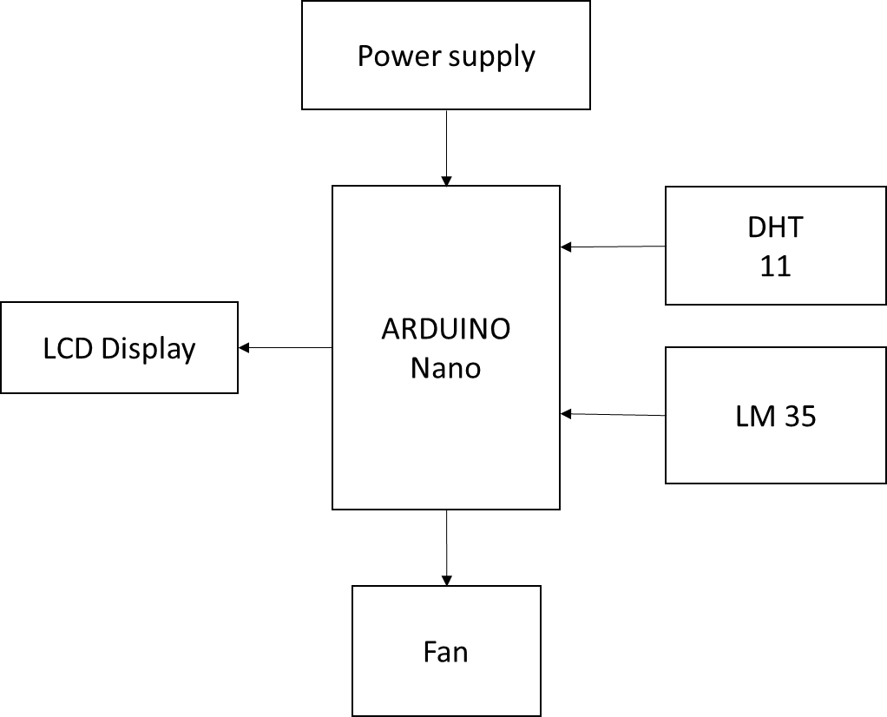

Figure 5.1: Block Diagram

CHAPTER 6  
COMPONENTS

6.1 Arduino Nano

The Arduino Nano is a compact microcontroller board with an ATmega328P chip, 14 digital pins, and USB connectivity. Ideal for space-constrained projects, it supports various applications such as robotics and wearables. The Nano is programmed through the Arduino IDE and offers a versatile solution for prototyping and embedded systems.

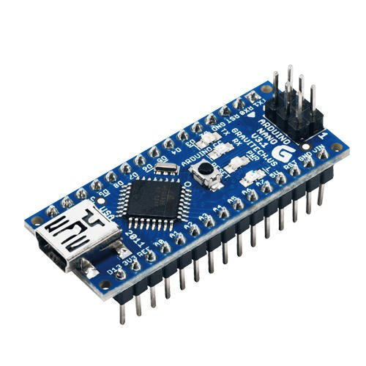

Figure 6.1: Arduino Nano

The Arduino Nano is employed in diverse projects due to its compact size and versatility. Common uses include robotics, electronic prototyping, wearable technology, sensor interfacing, and embedded systems development. With 14 digital pins, USB connectivity, and ease of programming, it's popular for creating innovative and space-efficient electronic applications. Arduino is an open-source electronics platform based on easy-to-use hardware and software. Arduino boards are able to read inputs - light on a sensor, a finger on a button, or a Twitter message - and turn it into an output - activating a motor, turning on an LED, publishing something online.

The Arduino Nano boasts a compact form factor, making it suitable for projects with limited space. With an ATmega328P microcontroller, 14 digital pins, and USB connectivity, it offers versatility and ease of programming. Its advantages include adaptability to diverse applications, making it a preferred choice for electronic prototyping and embedded systems.

6.2 DHT11 SENSOR

The DHT11 is a low-cost, digital temperature and humidity sensor commonly used in electronics projects. Featuring a calibrated digital signal output, it simplifies interfacing with microcontrollers like Arduino. With a measuring range of 0-50 degrees Celsius for temperature and 20-80% for humidity, it provides basic environmental data. The sensor employs a thermistor and a capacitive humidity sensor to measure temperature and humidity, respectively. Though less precise than some higher-end sensors, its simplicity, affordability, and ease of use make it popular for applications like weather stations, climate control systems, and home automation projects where moderate accuracy is sufficient[2].

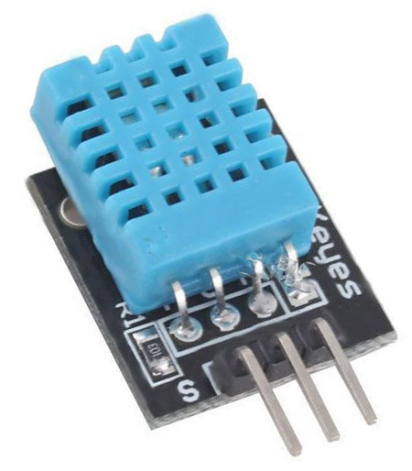

Figure 6.2: DHT11 Sensor

The DHT11 sensor finds diverse applications in monitoring and controlling environments. Its primary uses include climate control systems, where it measures temperature and humidity for optimal conditions. In home automation, it helps create smart systems that respond to changes in environmental parameters. Weather stations leverage the DHT11 to collect data for local climate monitoring. Agricultural setups benefit from its affordable sensing capabilities for crop management. Additionally, it's employed in various DIY electronics projects for enthusiasts exploring sensor integration. The DHT11's simplicity, low cost, and compatibility with platforms like Arduino make it a popular choice for projects requiring basic temperature and humidity measurements.

6.3 LM 35 SENSOR

The LM35 is a precision analog temperature sensor widely used in electronics for its simplicity and accuracy. Operating on a linear scale, it provides an output voltage directly proportional to the temperature in Celsius, with a sensitivity of 10mV per degree Celsius. With a wide temperature range and low self-heating, the LM35 is ideal for applications requiring precise temperature monitoring, such as climate control systems, thermal regulation in electronic devices, and industrial automation. Its straightforward analog output simplifies interfacing with microcontrollers, making it a popular choice for temperature-sensitive projects where reliable and real-time temperature data is essential.

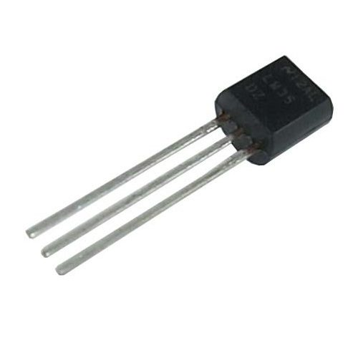

Figure 6.3: LM 35 Sensor

LM35 is a temperature sensor that outputs an analog signal which is proportional to the instantaneous temperature. The output voltage can easily be interpreted to obtain a temperature reading in Celsius. The advantage of lm35 over thermistor is it does not require any external calibration.

6.4 LCD DISPLAY

The LCD (Liquid Crystal Display) is a widely used flat-panel technology known for its versatility in presenting visual information. In electronics, character and graphical LCD displays provide a user-friendly interface, commonly interfaced with microcontrollers. Character LCDs show alphanumeric characters, while graphical LCDs display more complex graphics. Popular in devices like digital thermometers, clocks, and Arduino projects, LCDs offer a readable and space-efficient means to convey data. They come in various sizes, resolutions, and technologies like TFT (Thin-Film Transistor) for enhanced color displays. LCDs find applications in consumer electronics, medical devices, automotive displays, and various industrial control systems.

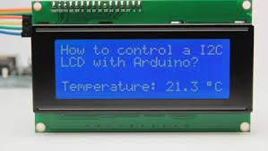

Figure 6.4: LCD Display

LCD displays find widespread applications across various industries due to their versatility and readability. In consumer electronics, they are used in digital clocks, calculators, and home appliances. Automotive systems incorporate LCDs in dashboards and navigation displays. In the medical field, LCDs are integral to devices like blood pressure monitors and patient monitoring systems. Industrial settings leverage them for control panels and data visualization. In the realm of DIY electronics, LCDs are popular in Arduino and Raspberry Pi projects for creating interactive and informative displays, showcasing their adaptability in diverse contexts.

6.5 VOLTAGE REGULATOR:

The LM7805 is a popular linear voltage regulator that outputs a stable +5V voltage from a higher input voltage source. It is widely used in electronics to provide a reliable power supply for various components and devices. The LM7805 requires input and output capacitors for stability and can handle a certain amount of current, typically up to 1A, making it suitable for low to moderate power applications. When connected correctly, it ensures a consistent +5V output, making it a straightforward and practical choice for voltage regulation in electronic circuits.

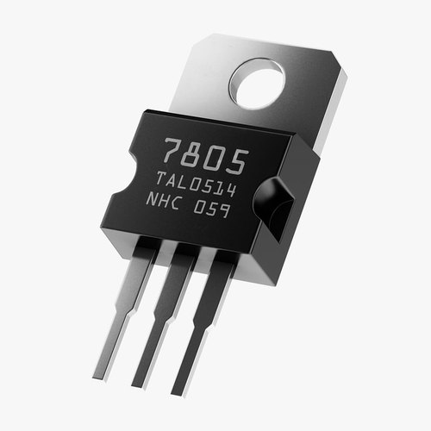

Figure 6.5: Voltage Regulator

A voltage regulator is an integrated circuit (IC) that provides a constant fixed output voltage regardless of a change in the load or input voltage. It can do this many ways depending on the topology of the circuit within, but for the purpose of keeping this project basic, we will mainly focus on the linear regulator. A voltage regulator generates a fixed output voltage of a preset magnitude that remains constant regardless of changes to its input voltage or load conditions.

The LM7805 is a popular linear voltage regulator that outputs a stable +5V voltage from a higher input voltage source. It is widely used in electronics to provide a reliable power supply for various components and devices. The LM7805 requires input and output capacitors for stability and can handle a certain amount of current, typically up to 1A, making it suitable for low to moderate power applications. When connected correctly, it ensures a consistent +5V output, making it a straightforward and practical choice for voltage regulation in electronic circuits.

6.6 TRANSISTOR:

The BC547 is a common NPN bipolar junction transistor widely used in electronics. It can amplify and switch electronic signals. With a maximum collector current (IC) of about 100mA, it's suitable for low-power applications. The BC547 is often used as a signal amplifier in small-signal circuits, such as audio amplifiers and signal processing circuits, where its gain and high input impedance are beneficial. When appropriately biased and connected in the circuit, the BC547 can amplify small input signals with accuracy. This transistor is typically available in a TO-92 package and is easy to use due to its standard pinout. It is important to ensure proper biasing and connections for the BC547 in your circuit, and its characteristics can be found in its datasheet for precise usage details.

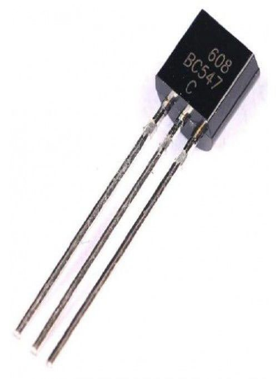

Figure 6.6: Transistor

CHAPTER 7  
SOFTWARE REQUIREMENT

The Arduino Integrated Development Environment or Arduino Software (IDE) - contains a text editor for writing code, a message area, a text console, a toolbar with buttons for common functions and a series of menus. It connects to the Arduino hardware to upload programs and communicate with them. The Arduino Software (IDE) makes it easy to write code and upload it to the board offline. We recommend it for users with poor or no internet connection. This software can be used with any Arduino board. In addition to a more modern editor and a more responsive interface it includes advanced features to help users with their coding and debugging.

Arduino boards are able to read analog or digital input signals from different sensors and turn it into an output such as activating a motor, turning LED on/off, connect to the cloud and many other actions. Easy to Learn and Use. The Arduino programming language is based on C++, with a simple and straightforward syntax that is easy to pick up even for beginners. To learn Arduino programming, start by reading the Arduino documentation and tutorials on the Arduino website. In addition, try building simple projects like blinking an LED, then progress to more complex projects and refer to online resources and forums for help. Practice and experimentation are key to mastering Arduino programming.

Arduino boards have limited memory and processing power compared to larger microcontroller boards or full-fledged computers. This can limit the complexity and size of projects built with Arduino. However, some Arduino boards have limited precision for analog to digital conversion, this could affect the accuracy of certain applications[7].

CHAPTER 8  
WORKING MODULE

The Temperature Based Automatic Regulator Using Arduino operates on the principle of feedback control. It utilizes a temperature sensor to constantly measure the current temperature of the environment. This data is then compared to a predefined setpoint temperature. If the measured temperature deviates from the setpoint, the Arduino microcontroller activates a control mechanism, such as a fan or a heater, to adjust the temperature back to the desired level. The system continuously monitors the temperature, ensuring it remains within the specified range. By receiving real-time temperature data and making automatic adjustments, the regulator maintains a stable and comfortable environment, making it ideal for applications like climate control in homes or offices.

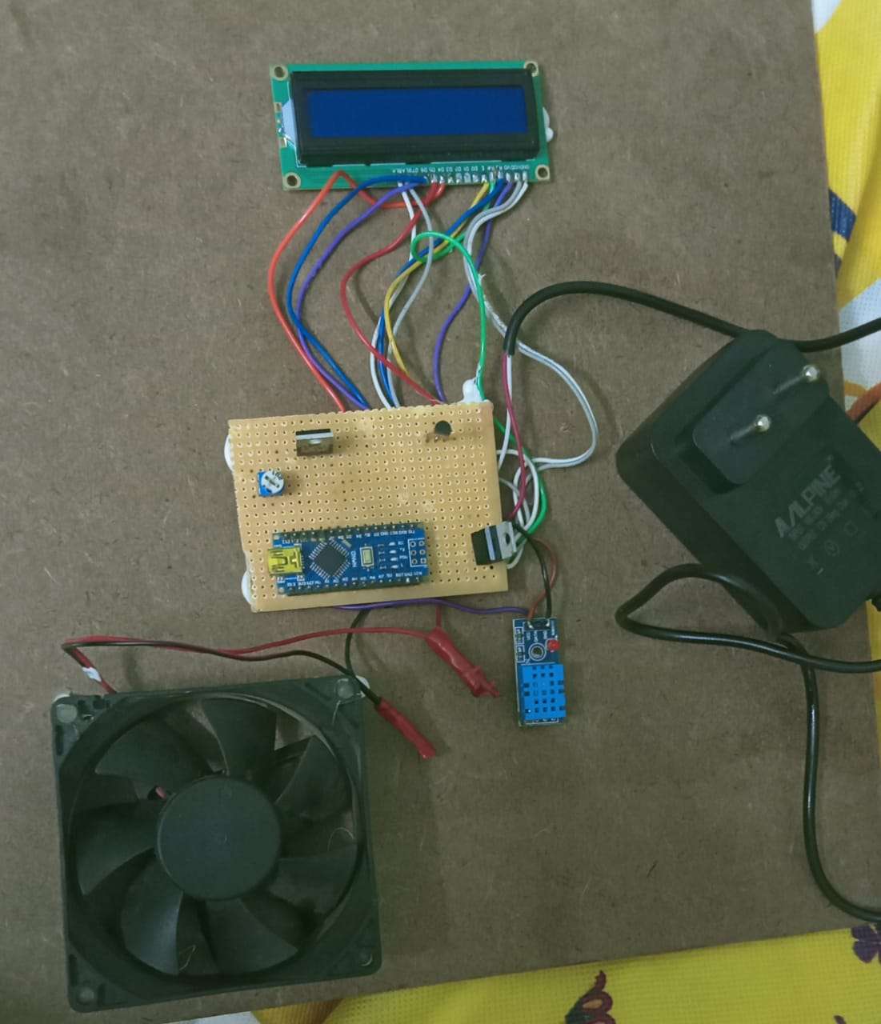

Figure 8.1: Working Module

This system employs temperature sensors such as thermistors or digital temperature sensors like DS18B20. These sensors work on the principle that electrical resistance changes with temperature variations. When the temperature changes, the resistance of the sensor also changes. The Arduino microcontroller reads this resistance value and converts it into a corresponding temperature value using a predefined algorithm. The Arduino, functioning as the brain of the system, processes this temperature data. It compares the measured temperature with a predefined setpoint temperature. The setpoint temperature is the desired temperature that the system aims to maintain. If the measured temperature deviates from this setpoint, the Arduino calculates the difference and determines the necessary action to regulate the temperature back to the desired range.

The Arduino interfaces with actuators like relays or solid-state switches, controlling devices such as heaters, air conditioners, or fans. For example, if the measured temperature exceeds the setpoint, indicating a need for cooling, the Arduino triggers the corresponding actuator to turn on the air conditioner or fan. Conversely, if the temperature falls below the setpoint, indicating a need for heating, the Arduino activates the heater. This process is continuous, creating a feedback loop where the system constantly monitors the temperature and adjusts the connected devices to maintain the desired temperature. The speed and accuracy of this regulation depend on the responsiveness of the sensors, the processing capabilities of the Arduino, and the efficiency of the connected actuators[4].

The Temperature Based Automatic Regulator Using Arduino operates by sensing temperature variations, processing this data through an Arduino microcontroller, and implementing control actions through actuators. This amalgamation of sensors, processing, and control mechanisms forms the foundation for its ability to regulate temperature automatically, offering a versatile and efficient solution for temperature control applications.

**CHAPTER 9**

**RESULT AND DISCUSSION**

The Temperature-Based Automatic Regulator Using Arduino demonstrated promising results in maintaining a stable environment by effectively controlling the temperature based on the input provided. The system utilized Arduino microcontroller technology and temperature sensors to monitor the surrounding temperature continuously. Through a series of experiments and tests, it was observed that the regulator accurately detected fluctuations in temperature and responded promptly to bring the environment back to the desired setpoint.

One of the notable outcomes of the experiment was the system's ability to maintain a consistent temperature within a narrow range. This is crucial in various applications, such as greenhouse cultivation or temperature-sensitive experiments in laboratories, where even slight temperature variations can adversely affect the desired outcomes. The accuracy and responsiveness of the Arduino-based regulator were evident during the tests, ensuring that the temperature remained within the preset limits.

Furthermore, the system demonstrated efficient energy utilization. By activating the heating or cooling devices only when necessary, the regulator optimized energy consumption, contributing to both environmental sustainability and cost-effectiveness. This energy efficiency is particularly significant in today's context, where energy conservation is a global concern.

In addition to its technical efficiency, the Temperature-Based Automatic Regulator Using Arduino also proved to be user-friendly and easily adaptable. The system's interface was intuitive, allowing users to set the desired temperature easily. Moreover, the system was highly customizable, enabling users to adjust various parameters according to specific requirements[6].

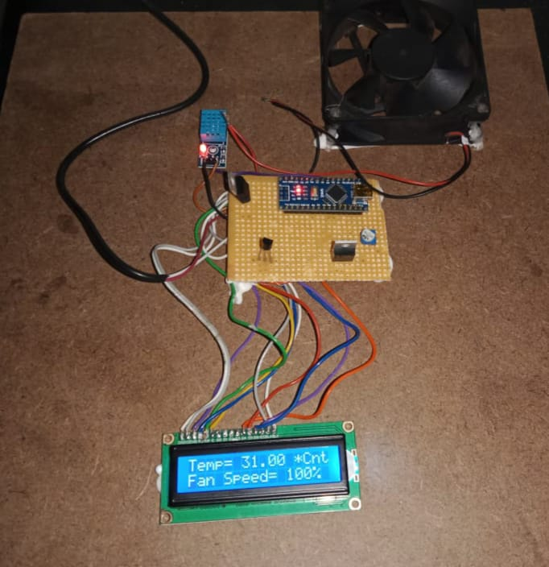

Figure 9.1: Overview of the Project

During the experimentation, the system also showcased its reliability and stability over extended periods. Continuous operation tests revealed minimal deviations from the target temperature over time, indicating the robustness of the Arduino-based regulator. This reliability is essential for applications that require long-term temperature control, ensuring consistent results and operational continuity. In conclusion, the Temperature-Based Automatic Regulator Using Arduino exhibited exceptional performance in maintaining a stable temperature environment. Its accuracy, energy efficiency, user-friendliness, adaptability, and long-term reliability make it a valuable solution for a wide array of applications, ranging from agriculture and research to industrial processes. The successful implementation of this system highlights its potential to enhance various fields where precise temperature regulation is paramount[3].

**CHAPTER 10**

CONCLUSION AND FUTURE WORK

In conclusion, the Temperature Based Automatic Regulator Using Arduino represents a significant leap forward in the realm of smart home technology and automation. Through the integration of advanced sensors, microcontrollers, and precise programming, this system exemplifies the potential of modern engineering in enhancing our daily lives. This project aimed to address the critical issue of energy efficiency and user convenience by automating the regulation of temperature within indoor environments. By employing an Arduino microcontroller, the system not only achieves remarkable accuracy in temperature control but also demonstrates the power of open-source hardware and software in driving innovation.

One of the primary achievements of this project is its contribution to energy conservation. Traditional heating, ventilation, and air conditioning (HVAC) systems often operate inefficiently, leading to unnecessary energy consumption and increased utility bills. The Temperature Based Automatic Regulator optimizes heating and cooling processes by responding dynamically to real-time temperature fluctuations. By efficiently managing the HVAC system, this technology reduces energy waste, resulting in considerable cost savings for homeowners and a positive environmental impact by lowering overall energy consumption.

Furthermore, this project exemplifies the user-centric design philosophy. The system offers a seamless and intuitive interface, allowing users to monitor and adjust the indoor temperature with ease. Through a user-friendly application or web interface, individuals can customize temperature settings according to their preferences and schedules. This level of customization not only enhances user comfort but also promotes a sense of control over the indoor environment, contributing to an overall improved quality of life.

Additionally, the Temperature Based Automatic Regulator prioritizes safety and reliability. The integration of fail-safes and real-time monitoring ensures that the system operates securely, preventing potential hazards such as overheating or system malfunctions. By employing state-of-the-art sensors and components, the system guarantees accurate temperature readings and precise control, instilling confidence in users regarding its performance and reliability[8].

FUTURE WORK:

The project's educational significance cannot be overstated. By delving into the realms of electronics, programming, and automation, students and enthusiasts gain practical insights into the complexities of control systems. This hands-on experience not only nurtures technical skills but also fosters creativity and problem-solving abilities, essential in today’s rapidly evolving technological landscape.

In essence, the Temperature Based Automatic Regulator using Arduino stands as a testament to the power of innovation and collaboration. It exemplifies the potential of merging cutting-edge technology with practical applications, driving us towards a more connected, efficient, and intelligent future. As the realm of automation continues to expand, this project serves as a beacon, illuminating the path for future advancements in smart control systems, making our world smarter, greener, and more sustainable.

APPENDICES

#include <One Wire. h>

#include <Dallas Temperature. h>

// Data wire is connected to pin 2 on the Arduino

#define ONE_WIRE_BUS 2

// Setup a one Wire instance to communicate with any One Wire devices

One Wire one Wire (ONE_WIRE_BUS);

// Pass the one Wire reference to Dallas Temperature

Dallas Temperature sensors (&one Wire);

// Pin connected to the relay module

int relay Pin = 3;

// Define the desired temperature threshold

float desired Temperature = 25.0; // Change this to your desired temperature in Celsius

void setup() {

// Start serial communication

Serial. begin(9600);

// Initialize the relay pin as an output

Pin Mode (relay Pin, OUTPUT);

// Start the sensor library

sensors. begin();

}

void loop() {

// Request temperature readings from the sensor

sensors. request Temperatures();

// Get the temperature value in Celsius

float temperature C = sensors. get Temp C By Index(0);

// Print the temperature value to the serial monitor

Serial. print("Temperature: ");

Serial. print(temperature C);

Serial. Println(" °C");

// Check if the current temperature is above the desired threshold

if (temperature C > desired Temperature) {

// If above the threshold, turn on the relay (heater, fan, etc.)

Digital Write (relay Pin, HIGH);

} else {

// If below or equal to the threshold, turn off the relay

Digital Write (relay Pin, LOW);

}

// Delay for a few seconds before taking the next reading

delay(5000); // Delay for 5 seconds (you can adjust this value based on your needs)

}

**REFERENCES**

[1] ] Liu, Y., Zeng, J. and Wang, C. (2009). Temperature Monitoring in Laser Assisted Polymer Bonding for MEMS Packaging Using a thin Film Sensor Array , IEEE Sensors Applications Symposium, New Orleans, LA , USA.

[2] Jung, W.,You, J. and Won, S. (2008). Temperature Monitoring System for Inductive Heater Oven (pp.1734-1737), International Conference on Control, Automation and Systems, Seoul Korea.

[3] Electronic components- D.V. Prasad, International journal of computer applications (1904-5607)volume 81-No5, November 2020.

[4] Mustafa Saad, Hossam Abdoalgader, and Muammer Mohamed, “Automatic Fan Speed Control System Using Microcontroller” 2021.

[5] Kunal Singh, Moloy Dhar, Pritam Roy,” Automatic fan speed control system using Arduino”, International Journal of Novel Research and Development 2022.

[6] Surabhi, “ Design & Fabrication of temperature based DC Fan Speed Control system using Microcontroller & PWM Technique”,IJRSET Vol.4, Issue 7, July 2015.

[7] Vaibhav Bhatia & Gavish Bhatia “ Room Temperature based fan speed control system using PWM techniques”, International journal of computer applications (0975-8887)volume 81-No5, November 2013.

[8] Ghana Shyam Soren, Ram Ashish Gupta, “ Temperature controlled DC fan using Microcontroller”, National institute of technology- Rourkela. Pramana Research Journal Volume 10, Issue 4, 2020.

OUTCOME

